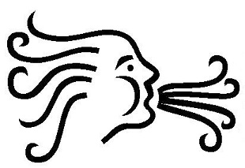

AIR Artsy Accessories

Please contact us if you are not satisfied with your purchase. We are more than happy to resolve any problems you may have. We cannot refund the shipping cost if the purchase has already shipped. Your satisfaction is our priority and we want you to be happy with your purchase.

If you do not like your purchase for any reason please contact us within 7 days of receiving and we'd be happy to take it back as long as the items are unused, unworn, unwashed and in original condition. We will issue a full refund when the item is received back as long as the item is received within 14 days of initial return request and passes the inspection.

**Please note that any shipping upgrades will not be refunded and buyers are responsible for return of the items.

